Based on the analysis below, I recommend $4638.06 for 1 product each and $6637.70 for at most 2 products each. Also suggest adding markup to account of price fluctuations, shipping, and tax.

|  |  |  |  |  |  |  |
| --- | --- | --- | --- | --- | --- | --- |
|  | **Simulated Runs** | **Minimum Cost ($)** | **Average Cost ($)** | **Maximum Cost ($)** | **Product Count** | **Product Count over 845 products** |
| **1 product each** | 5172 | 3220.78 | 3631.91 | 4638.06 | 186 | 22.01% |
| **2 products each** | 5120 | 4902.52 | 5431.75 | 6637.7 | 272 | 32.19% |

The result of price simulation for at least 1 product per company. A total of 5172 runs, the average cost is $3631.91, the minimum cost is $3220.78, and maximum cost is $4638.06.

The result of price simulation of picking at least 2 products per company. Out of total run of 5120, the overall averaged cost is $5432.75, minimum cost is $4902.52, and maximum cost is $6637.70.

There are 186 companies carrying 845 products on our list. Out of 186 companies, 100 companies carry 1 product entry, 25 companies carry 2 product entries, 8 companies carry 3 product entries. Picking maximum of 1, 2 or 3 products per company means testing 22%, 32%, 39% of selected samples respectively. Most of the products are priced between the 0-50 dollars range. And most of the companies carry less than 10 products.

Selected sample accounted for duplicate products from Clearya, products intended for Professional use or service-based product and cannot buy, products that cannot be shipped to California, products that are unavailable to purchase online, and out of scope products. The data assumes that the price has not changed from data collection. The data also assumes that any variation of company spelling is considered as sperate companies.

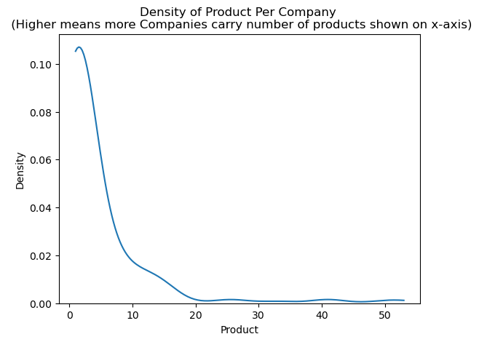

Gordon Lai

11/30/2023